Program 1

Aim: Write A Program to obtain length and breadth of a rectangle and calculate its area

Code

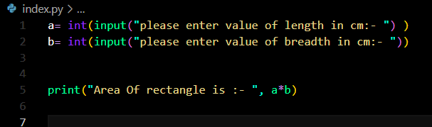

Output

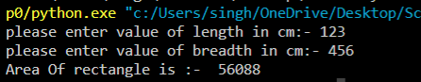

Program 2

Aim:- WAP to input a value in kilometres and convert it into miles (1 km = 0.621371 miles)

Code:

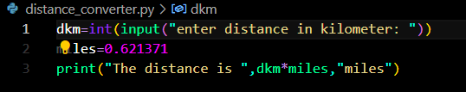

Output:



Program 3

Aim:- WAP to print Fibonacci series first 20 elements. Some initials elements of a Fibonacci series are :- 0 1 1 2 3 5 8...

Code

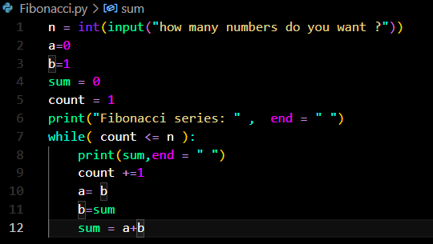

Output



Program 4

Aim:- WAP to check if a given number is an Armstrong number or not.

Code:

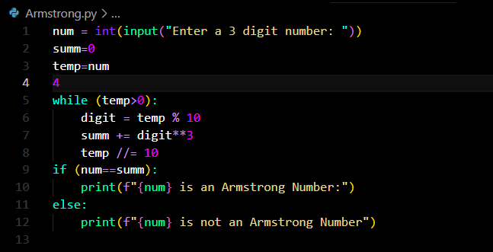

Output



